
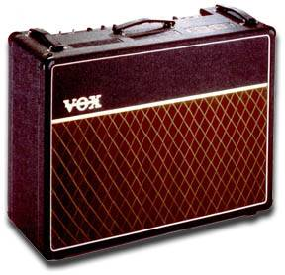

Vox AC30 Amplifier
The specifications of the Vox AC30/6 TB are the result of painstaking research by our guitarists and engineers, who were not happy until they re-created the amp that started it all. The result is a faithful reproduction in sound and style of those pioneering Vox amps of the early 60s.
Control Panel
The AC30/6 TB control panel layout is the same as the original, even to the point of being back to front! You will notice that we have added a standby switch; this is intended to prolong the life of the valves, by stopping the surge of electricity when the unit is switched on.
Valve Configuration
The valve line-up of the AC30/6 TB is as follows: Five ECC83s and one ECC82 in the preamp stage, with four EL84s in the power stage operating in Class A, plus a GZ34 rectifier valve in the power supply, for that unique Vox tone and feel.
Design
The AC30 comes with original diamond fret cloth reproduction and Vox’s famous basketweave vinyl covering, and the cabinet is made of birch ply throughout, to original specifications. Other Vox cosmetic features, such as the authentic Vox handles, are also true to the original. The vent grilles have been enlarged to allow for improved ventilation. This provides longer valve life and improves amplifier performance.
Specifications:
The AC30/6 TB circuit is a faithful copy of the circuit designed by Dick Denney, Vox design engineer from 1957 to 1965. 33 Watts RMS before distortion, Six inputs, Hi and low for each channel, Brilliant, Normal and Vibtrem. Each channel has its own volume control. The Brilliant channel has Bass and Treble tone controls. A cut controls acts as an additional tone for all channels. There is a Speed control and Vibtrem selector for Vibtrem channel. An authentic Vox oval die cast “egg” footswitch is included.
Dimensions: 705mm(w) x 265mm(d) x 550mm(h) / 27 3/4"(w) x 10"(d) x 21"(h).
Weight: 32Kg / 70lbs.

Top Panel Layout
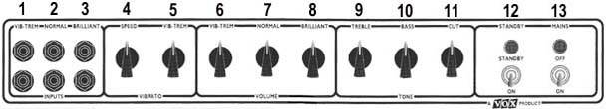

Top Panel Features
- Vib/Trem Inputs. Standard 1/4" jack sockets for connection of the lead from the guitar. These two Inputs are for the Vib/Trem channel only.
- Normal Inputs. Standard 1/4" jack sockets for connection of the lead from the guitar. These two Inputs are for the Normal channel only.
- Brilliant Inputs. Standard 1/4" jack sockets for connection of the lead from the guitar. These two Inputs are for the Brilliant channel only.
- Tremolo Speed Control. Controls the speed at which the built in tremolo oscillates.
- Vib/Trem Switch. Selects either Vib or Tremolo settings for the built-in tremolo. Selective Vib will decrease the intensity of the tremolo.
- Vib/Trem Volume Control. Controls the volume of the AC30's Vib/Trem channel.
- Normal Volume Control. Controls the volume of the AC30's Normal channel.
- Brilliant Volume Control. Controls the volume of the AC30's Brilliant channel.
- Treble Control. Adjusts the higher frequencies or treble in your tone on the Brilliant channel, from soft and full at one extreme to bright and cutting at the other.
- Bass Control. Adjusts the lower frequencies or bass in your tone on the Brilliant channel, from warm and light at one extreme to dark and heavy at the other.
- Cut Control. A variable tone control for all channels, reduces high frequency content for a smoother tone.
- Standby Switch & Indicator. Controls the H.T. supply to the valves and allows them to remain heated when not in use. (Ideal for leaving the amp in a ready state during breaks). Amber neon lamps indicate standby on.
- Power ON/OFF Switch & Indicator. On/Off switch for mains (AC) power to amplifier. Red neon lamps indicate power on.

Rear Panel Features | Speaker Options
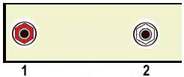 | The AC30TB is fitted with a pair of Celestion G12M "Green Backs" twelve inch speakers.  The AC30TBX is fitted with a pair of Celestion made Vox "Blue" Alnico magnet speaker.
- Speaker Output Jack (red). For connection to the internal loudspeaker.  - Tremolo Footswitch Jack. For connection to the external on/off footswitch for Tremolo. | 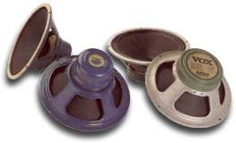
Included Accessories | AC30 Valves
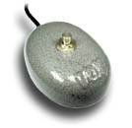  Vintage style "egg" footswitch housed in rugged diecast metal casing for control of Tremolo. | The AC30's valve line up includes a GZ34 rectifier valve in the power supply circuit. This is a key ingredient to giving that classic vintage tone.  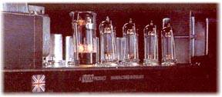  The quartet of EL84 valves operate in a "Class A" bias configuration.

